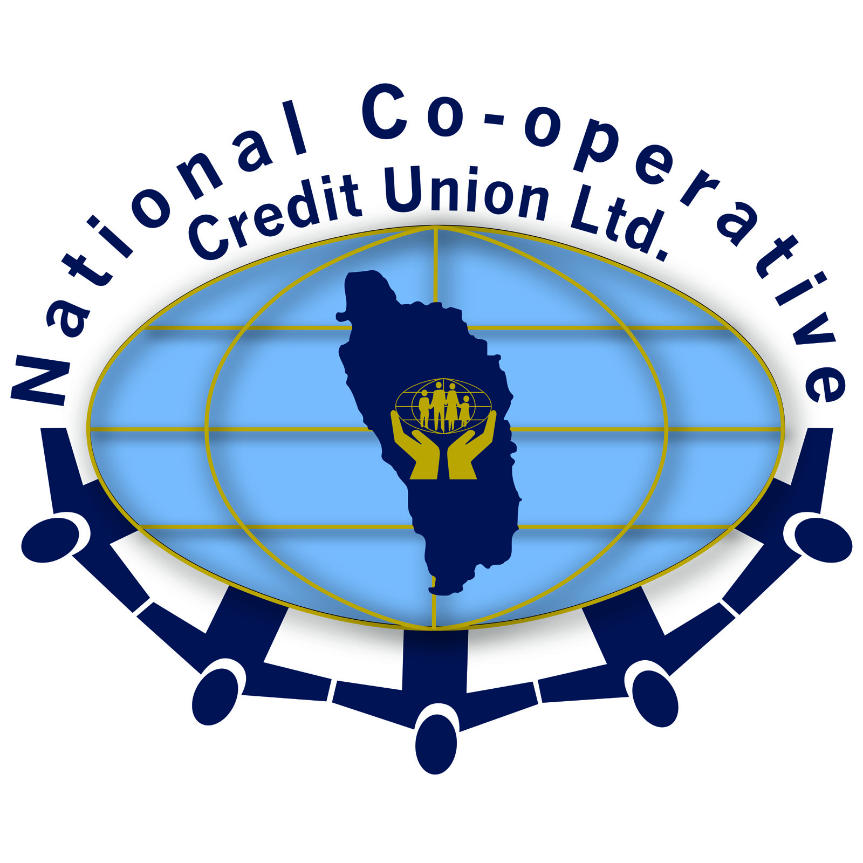
NATIONAL COOPERATIVE CREDIT UNION LTD

PLEASE RETURN BY AUGUST 31, 2016

IMPORTANT:
PLEASE COMPLETE ALL SECTIONS FULLY [NO BLANKS] - INCLUDE THE ACCEPTANCE LETTER. PROVIDE ALL INFORMATION REQUIRED. INCOMPLETE FORMS WILL NOT BE CONSIDERED.

APPLICATION FORM FOR NCCU LTD PARTIAL SCHOLARSHIP TO ATTEND THE DOMINICA STATE COLLEGE

PLEASE TICK [√] AS APPROPRIATE: IF NEED PLEASE COMPLETE SECTION SEVEN (7)

Male Female Need Merit

1 NAME OF STUDENT:

FIRST / MIDDLE NAME (S) LAST NAME

2 SECONDARY SCHOOL ATTENDED:

3 NCCU LTD ACCOUNT NUMBER:

SUBJECT PASSES AT BASIC PROFICIENCY NOT ACCEPTED

4 CXC or GCE GRADES OBTAINED: [PLEASE ATTACH RESULTS SLIP]
SUBJECT | PROFICIENCY
SUBJECT | GENERAL

APPLICANT'S COURSE OF STUDY MUST BE IN LINE WITH NCCU LTD BUSINESS/ACTIVITY

5 COURSE OF STUDY:
[Please attach copy of acceptance letter from the Dominica State College]

- NAME OF PARENTS/GUARDIANS:

Name of Mother/Guardian [Delete as appropriate]:

Address:

Telephone Number(s):

Mother/Guardian Email Address:

Mother/Guardian NCCU Ltd Account Number:

Mother/Guardian Employer:

Job title / Position [Mother/Guardian]:

Monthly/ Weekly income [Mother/Guardian]: $

Name of Father/ Guardian [Delete as appropriate]:

Address:

Telephone Number(s):

Father/Guardian Email Address:

Father/Guardian NCCU Ltd Account Number:

Father/Guardian Employer:

Job Title/ Position [Father/Guardian]:

Monthly/ Weekly income [Father/Guardian]: $

IF APPLICATION IS BASED ON NEED PLEASE SEE BELOW. [Please attach recent salary slip]

- REASONS FOR REQUESTING FINANCIAL ASSISTANCE:

d.

8 APPLICANT’S SIGNATURE DATE

9
SIGNATURE OF PARENTS/GUARDIAN DATE

PLEASE RETURN ON OR BEFORE AUGUST 31, 2016

